**LCPro**

1. Open **Image J** program.
2. Drag LSM file to Image J
3. Duplicate file-

**Image**🡪 **Duplicate**

Title: *(Please make sure that you remove the last number that adds automatically and add d- to the front of the file name) (d= duplicate, Ex: d-042314_AN_MCA_100uMPE-Ctrl)*

*□* Check the box for Duplicate stack

Range: keep all the frames unless you want to make the recording shorter

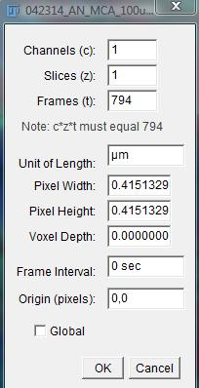

1. 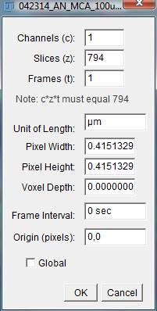Convert to **8-bit**

**Image**🡪 **Type**🡪 **8-bit**

1. **Image**🡪 **properties**🡪 **swap (t) with (z) values**

*[So (t) will always be 1]*

1. Click **Analyze**🡪 **set scale**🡪

Click **“Click to Remove Scales”** 🡪 ok

1. Save as TIFF into folder labeled “d-file name”
2. Click **Plugins**🡪 **Registration**🡪 **StackReg**

Select **Rigid Body**🡪 ok

*(Don't click credits! This will go through the recording frame by frame and will adjust for movement, can take a while so please don’t press other buttons because it can disturb the stacking)*

1. Save as TIFF into folder and label “d-r-file name”

*(r= reg Stack, this will help you keep track of what you have done to the file)*

*(Ex: d-r-042314_AN_MCA_100uMPE-Ctrl)*

1. Open your file: *(only if you closed it after you save it)*
2. Checking for black borders:

*\*Note: before cropping check if there is black edges by opening the* ***“Brightness and Contrast”*** *window (Image🡪 Adjust🡪* *Brightness/Contrast)*

* 1. Scroll the maximum bar to the left until you see the image really bright
  2. Scroll through the recording to see if you can see black edges
  3. After using this feature you can click **Reset** so you won’t save the image that is adjusted!

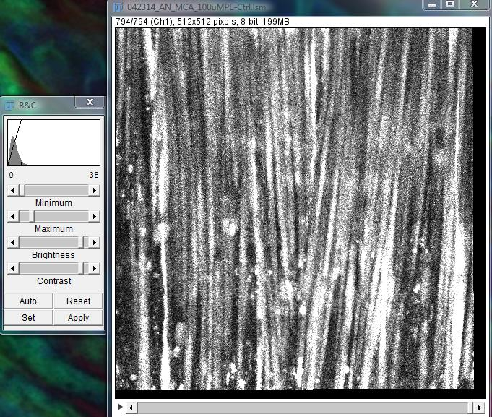

Max bar to Left

For this particular sample its best to crop 490x490 Top-Left

*This will help keep more information and crop less*

Black borders on Bottom- Right

1. Adjusting the canvas size:

**Image**🡪 **Adjust**🡪 **Canvas Size**

* 1. 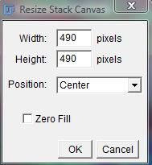If the black edges are even on the edges crop

**490x 490 Center**

* 1. If the black edges are to one side you can crop by using **Position**:

Top- left/ Top-center/ Top-right/ Center-left/ Center/ Center-Right/ Bottom-left/ Bottom-center/ Bottom-right

*(This feature will let us keep more information that is needed by only cropping what is needed)*

* 1. Scroll through the recording again after you cropped to double check that you don’t have black edges! Important because black edges will interfere when the ROI’s are being found!

1. Save as TIFF into folder and label “c-d-r-file name”

*(C=crop, this will help you keep track of what you have done to the file)*

*(Ex: c-d-r-042314_AN_MCA_100uMPE-Ctrl)*

1. Close the image
2. Open the folder where all the files where saved and **create a subfolder** where you drag the (d-file and d-r-file) *These are just backup files so when you make a mistake you won’t have to start from the beginning!* (*Ex: d-r-042811_AN_PE-1 and d-042811_AN_PE-1)*

**\*\*Extremely important that you only have the c-d-r-file out!!!\*\***

1. Ready to run LCPro:

**Plugins**🡪 **LCPro**

**LC_Pro Settings:**

ROI (pixels): this diameter size will vary with experiments

*(Frequent sizes are: Endothelial cells 12, Smooth muscle cells 6)*

Frame Rate (fps): 1.28

P- Value: 0.05

1. Choose the Image Directory

*Direct it to where the c-d-r-file is at*

1. Click OK and LCPro will start running and finding all the potential ROIs

1. After LCPro completes a new folder will appear

*(Drag the c-d-r-file into the new folder that was created with Output at the end)*

*(EX: c-d-r-042314_AN_MCA_100uMPE-Ctrl.tif Output), this will keep you organized when having multiple files!*

*\*Now you can delete the d-file and d-r-file! These where just backup files in case you made a mistake you didn’t have to start from the beginning!*

**R Script**

1. Open **R** program.
2. Click **File**🡪 **Open script**

Direct to desired script (labuser🡪 Documents🡪 My Dropbox🡪 Image J macros🡪 **R Scripts**)

*No treatment: “traceplotspon_no treatment_final.R”*

*With treatment: “traceplot_treatment_final.R”*

*Select **traceplotspon_no treatment_final.R**

*The **R Editor** will pop up

3. Click **R console** (just click anywhere on the console and make sure that it on top):

4. Click **File**🡪 **Change dir**

*Set directory to where the Output files of interest are under that were made from LC Pro*

(EX: C:\labuser\Desktop\SW-LL\ c-d-r-042314_AN_MCA_100uMPE-Ctrl.tif Output)

Click **OK**

5. In the R Console type **" getwd()"**

This will give the directory name of the file

6. Copy the directory name from **"C: .............."**

*(EX: C:/Users/labuser/Desktop/SW-LL/ c-d-r-042314_AN_MCA_100uMPE-Ctrl.tif Output) 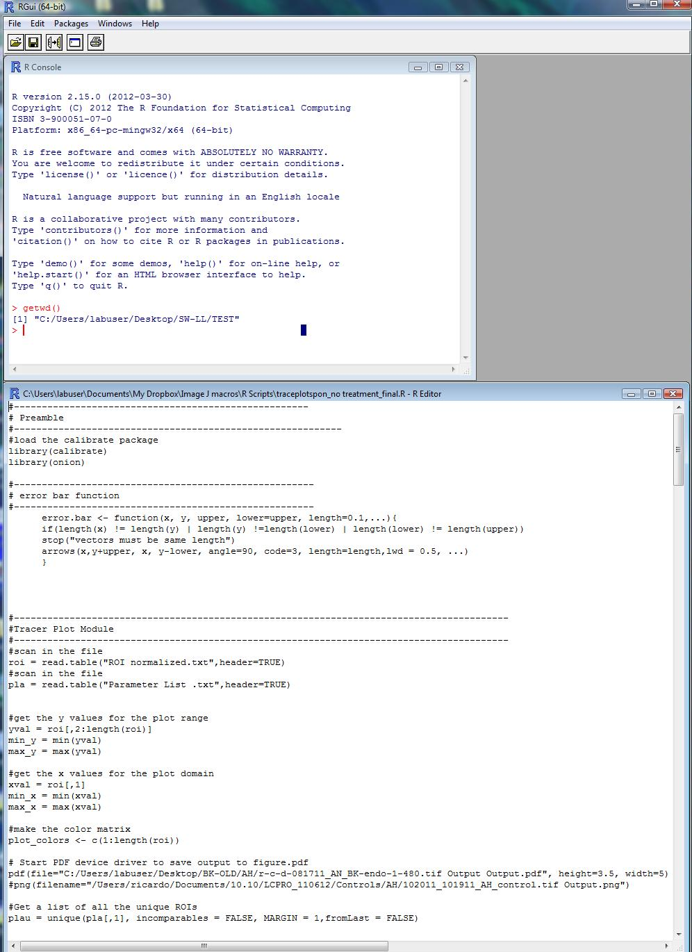*

Change the directory name to the one getwd() gives you

getwd()

7. In the **R Editor**.....

Scroll down till **"# Start PDF device driver to save output to figure.pdf”**

Delete old and add new directory name [The one you got from getwd()]

** **ALWAYS** leave one Output at the end!!! **

***EX:***

*# Start PDF device driver to save output to figure.pdf*

*pdf(file="~~C:/Users/labuser/Desktop/BK-OLD/AH/r-c-d-081711_AN_BK-endo-1-480.tif Output~~ Output.pdf", height=3.5, width=5) #png(filename="/Users/ricardo/Documents/10.10/LCPRO_110612/Controls/AH/102011_101911_AH_control.tif Output.png")*

CHANGE TO THIS:

*# Start PDF device driver to save output to figure.pdf*

*pdf(file="****C:/Users/labuser/Desktop/SW-LL/ c-d-r-042314_AN_MCA_100uMPE-Ctrl.tif Output*** *Output.pdf", height=3.5, width=5) #png(filename="/Users/ricardo/Documents/10.10/LCPRO_110612/Controls/AH/102011_101911_AH_control.tif Output.png")*

7. Click **Edit**🡪 **Run all**

*(This will run through all the LCPro outputs and generate pdf files with graphs that will have events and ROI numbers)*

8. After the console is done the pdf file will be saved back in the folder where the LCPro data is at.

*(Drag the PDF file into the output folder were all the data is stored, this will keep you organized)*

*\* You should have 4 files in total*

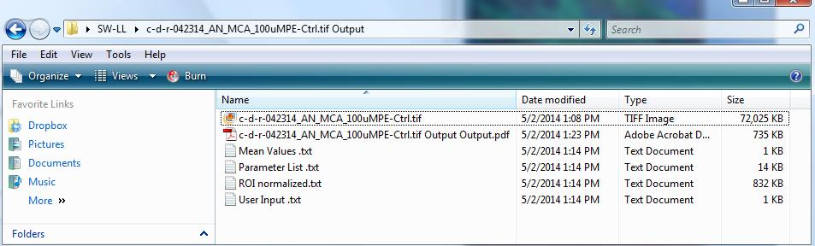

**Parsing the Data**

Use the PDF outputs to look at the Fluorescence Intensity vs Time to sort real events vs “junk” events.

Examples:

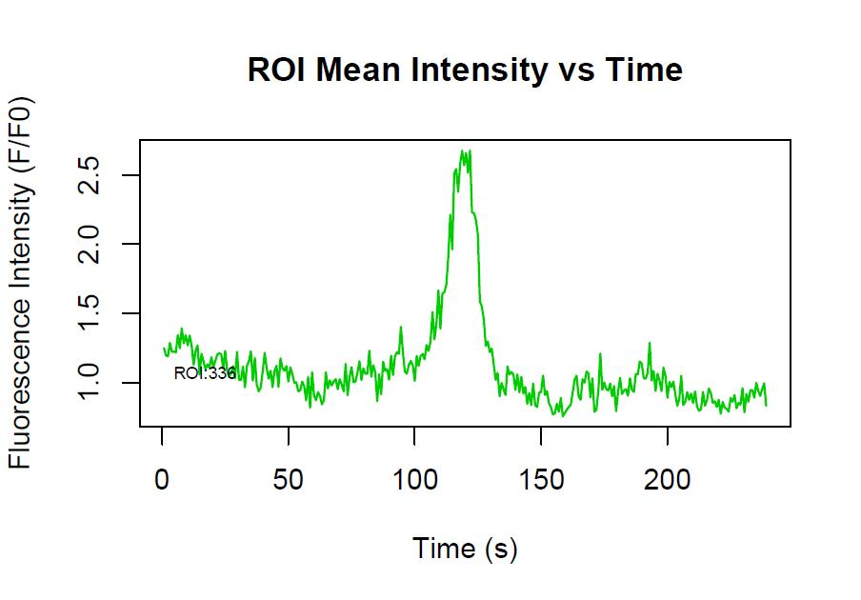

This PDF trace has a sharp peak that is a representative of a **good** event. The graph also includes the ROI number 336 which can help you double check the event. You can check the events by using the ROI Selectionv2 and parameter list to overlay the coordinates on the video.

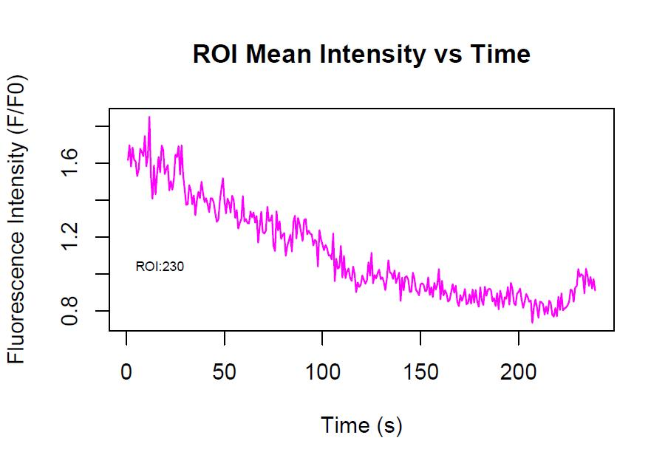

This PDF trace is an example of a **bad** event, where no peaks are present.

**Creating a spatial Overlay of the cells with ROI events**

*(Creating an overlay from a file using the parameter list from LCPro can help parse out data that looks “off” and also may be used for creating a picture that includes ROIs for a poster)*

1. Open **Fiji** (ImageJ)
2. Drag file onto Image J
3. **Load** ROI Selectionv2

**Plugins**🡪 **Macros**🡪 **Install**🡪

labuser🡪 Documents🡪 My Dropbox🡪 Image J macros🡪 **ROI Selectionv2.ijm**

1. Run plugin:

**Plugins**🡪**Macros**🡪**ROI Selectionv2**

1. Select **Parameter List** *(with in the LCPro data folder)*
2. All of the event will now be loaded onto ROI Manager.
3. Click **Show All** *(In the ROI Manager window, this will let you view all events)*
4. Click **Flatten** if you want to save the overlay ROI’s as an image

**ROI manager Tab the coding:**

**axes**

**Y X**

**0001-0014-0082**

**When you are trying to see if the activity is real**